; OurScheme Intro. (modified from MIT Scheme) (version : 2011-05-11)

; Meaning vs. representation --- on the abstract level
;
; We communicate with each other. We communicate with the system.
;
; When we communicate, we have no choice but to use some
; symbolic expression to convey our meaning (the "things"
; that we mean).
;
; Each symbolic expression (if legal) ought to mean something.
; Each symbolic expression (if legal) has a MEANING.
;
; We use symbolic expressions to convey our meaning.
; The system understands our meaning.
; Sometimes, the system is asked (by us) to do what we mean.
; When the system has a result to show to us, it has no choice
; but to show a symbolic representation of it. Supposedly,
; we know what the expression (what the system shows) means.

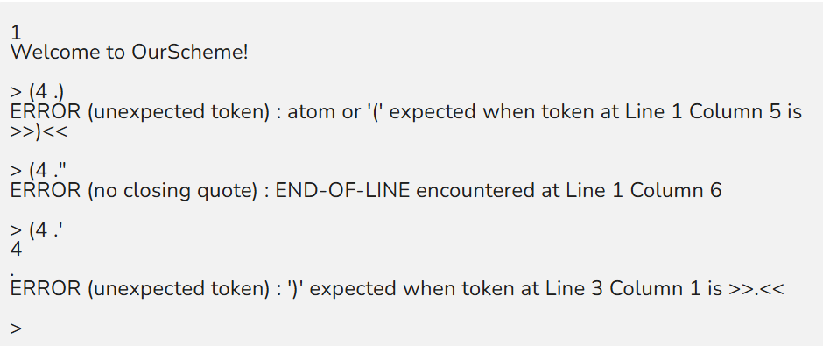
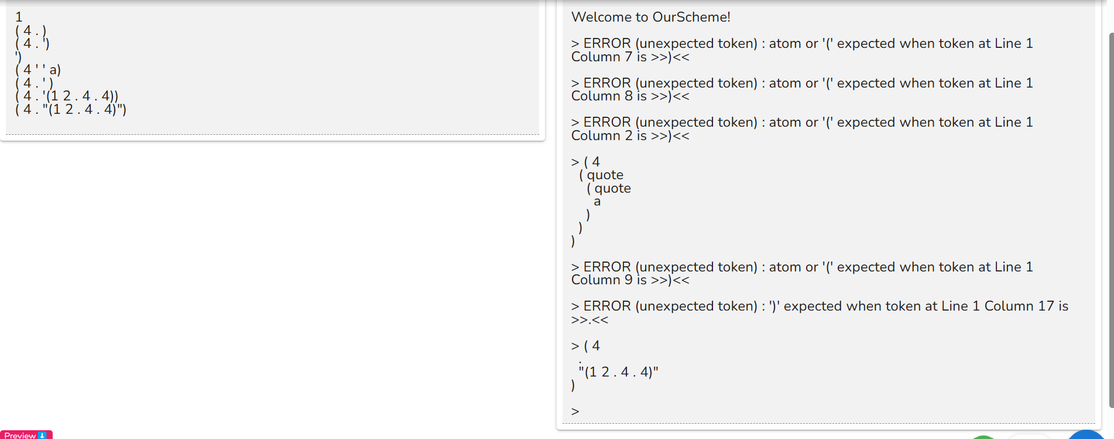
; 1. A list (or a dotted pair) is CONSTRUCTED.

> (cons 3 4) ; an operation on two objects
(3 . 4) ; a representation of the resulting object

> (CONS 3 4)
ERROR (unbound symbol) : CONS

; When evaluating an S-exp, Scheme/Lisp treats the first token
; after '(' as a function call

; 'cons' is a shorthand for "construct";
; implementation aspect : a CONS-cell is created

; OurScheme distinguishes between upper and lower cases
; // However, Petite Scheme does not.

> (list 3 4) ; another operation on two objects
(3 4) ; a representation of the resulting object

; Notice the difference between (3 . 4) and (3 4)

; 2. To "by pass" the default interpretation of an S-exp
; by the system, use QUOTE.

> (3 4 5)
The object 3 is not applicable ; // or "Invalid function: 3"

> '(3 4 5)
(3 4 5)

> (quote (3 4 5))
(3 4 5)

> (cons 3 (4 5))
The object 4 is not applicable ; // or "Invalid function: 4"

> (cons 3 '(4 5))
(3 4 5)

> (list 3 '(4 5))
(3 (4 5))

> (list 3 '(4 5) 6 '(7 8))
(3 (4 5) 6 (7 8))

; 3. To give a (symbolic) name to an object

> a
ERROR (unbound symbol) : a

> (define a 5) ; "令a為5"; 讓我們把"那個東西"又稱為'a'
a defined

> a ; is 'a' a name for something?
5 ; yes, 'a' is a name of "this thing"

> (define x '(3 4 5)) ; 讓我們把"那個東西"又稱為'x'
x defined

> x ; Is 'x' a name for something?
(3 4 5) ; 'x' is a name of "this thing"

// In addition, 'define' can only be called on the top level ;
// If 'define' is called on any "inner level", it will be an error ;

; 4. Whenever a function is called, its parameters are evaluated
; first.

>(cons 3 4)
(3 . 4)

>(cons 3 b)
ERROR (unbound symbol) : b ; or "Symbol's value as a variable is void: b"

>(cons 3 a)
(3 . 5)

>(define a '(3 4))
a defined

>(cons 5 a)
(5 3 4)

; 5. Different parts of a list (or a dotted pair) can be
; individually accessed

> (car '(3 4)) ; CAR is used to access the "left part" of
3 ; the "starting" CONS-CELL
; The other way of seeing it is to say that
; CAR accesses the first element of a list

> (car '((3 4) 5) )
(3 4)

> (car '((3 4) 5 . 6) )
(3 4)

> (car '((3 4) . 5) )
(3 4)

> (car a)
3

> (cdr '((3 4) 5) ) ; CDR is used to access the "right part"
(5) ; of the "starting" CONS-CELL
; The other way of seeing it is to say that
; CDR accesses the "remaining part" of a list

> (cdr '((3 4) 5 . 6) )
(5 . 6)

> (cdr '((3 4) . 5) )
5

> (cdr a)
(4)

; Different parts of a list can be accessed by mixing the use of
; CAR and CDR

> (car (cdr '((3 4) 5) ))
5

> (car (cdr '((3 4) 5 . 6) )
5

> (car (cdr '((3 4) 5 6 7) ))
5

> (cdr (cdr '((3 4) 5 6 7) ))
(6 7)

; 6. User defined functions can be created
; To give a name to a function

> (define (f x y) (cons y x)) ; Other Lisps use
f defined ; DEFUN
; e.g.,
; (defun f (x y) (cons y x))

> (f 3 4)
(4 . 3)

> (define b '(5 6 7))
b defined

> (f a b)
((5 6 7) 3 4)

> (define (g x y)
(* (+ x y)
(* x y))
)
g defined

> (define (h x y)
(+ x y)
(* x y)
)
h defined

> (g 3 5)
120

> (h 3 5)
15

; 7. Primitive predicates (A predicate is a function that returns
; "true" or "false"; By convention, the name of a predicate
; should have a suffix '?')

> (pair? 3) ; Other Lisps do not have PAIR
nil ; They have ATOM, which returns the opposite
; logical value
; e.g.,
; > (atom 3)
; #t

> (pair? '(3 4))
#t ; > (atom '(3 4))
; nil

> (pair? '(3 . 4))
#t

> (pair? "Hello, there!")
nil

> (null? '()) ; is it the empty list?
#t ; yes

> (null? #f)
#t

> (null? '(3 . 4))
nil ; no, it is not the empty list

> (integer? 3)
#t

> (integer? 3.4)
nil

> (real? 3)
nil

> (real? 3.4)
#t

> (number? 3)
#t

> (number? 3.4)
#t

> (string? "Hi")
#t

> (string? 3.4)
nil

> (boolean? #t)
#t

> (boolean? '())
#t

> (boolean? #f)
#t

> (boolean? '(3 . 4))
nil

> (symbol? 'abc)
#t

> (symbol? 3)
nil

; 8. Basic arithmetic, logical and string operations

> (+ 3 7)
10

> (- 3 7)
-4

> (- 3.2 5)
-1.79999999999999998

> (* 3 4)
12

> (define a 5)
a defined

> (/ 15 a)
3

> (/ 15.1 4)
3.775

> (/ 15.1 (+ 2 2))
3.775

> (not #t)
nil

> (not (pair? 3))
#t

> (and (pair? 3) (null? '()) )
nil

> (or (pair? 3) (null? '()) )
#t

> (> 3 2)
#t

> (> 3.1 2)
#t

> (>= 3.2 2)
#t

> (< 3.1 2)
()

> (<= 3.1 2)
nil

> (= 2 2)
#t

> (string-append "Hello," " there!")
"Hello, there!"

> (string>? "abc" "abc")
nil

; 9. eqv? and equal?

; eqv? returns "true" only when the two being compared
; objects are atoms (except in the case of strings)
; or when the two being compared objects "occupy the
; same memory space".

1. The two arguments of 'eqv?' OUGHT TO BE evaluated first.

2. Let the evaluated result of the first argument be ★.
Let the evaluated result of the second argument be ☆.

3. 'eqv?' returns '#t' if
★ ☆ are the same atom (except in the case of strings)
or
★ ☆ (including the case of strings) occupy the same memory space

4. 'eqv?' returns 'nil' otherwise.

Example :

> (eqv? a a)
ERROR (unbound symbol) : a

> (define a '(1 3))
a defined

> (eqv? a a)
#t

> (define b a)
b defined

> (eqv? a b)
#t

> (eqv? '(1 3) '(1 3))
nil

> (eqv? a (car (cons a '(2 3))))
#t

> (eqv? "Hello, there" "Hello, there")
nil

> (define a "Hello, there")
a defined

> (eqv? a "Hello, there")
nil

> (eqv? a (car (cons a '(2 3))))
#t

> (define a 1)
a defined

> a
1

> (eqv? a 1)
#t

> (eqv? "Hi" "Hi")
nil

> (define a 'a)
a defined

> a
a

> (eqv? a 'a)
#t

> (define b 'a)
b defined

> (eqv? a b)
#t

> (define a 'abc)
a defined

> (define b 'abc)
b defined

> (eqv? a b)
#t

> (eqv? a 'abc)
#t

; equal? corresponds the usual notion of
; equality comparison

> (equal? a a)
#t

> (equal? '(3 4) '(3 4))
#t

> (equal? "Hi" "Hi")
#t

; 10. Conditionals

> (if (> 3 2) 'good 'bad)
good

> (if a 'good 'bad)
good

> (if (not a) 'good 'bad)
bad

> (cond ((> 3 4) 'bad)
((> 4 3) 'good)
(else "What happened?") ; even though 'else' is unbound
)
good

> (cond ((> 3 4) 'bad)
((> 4 5) 'bad)
(#t "What happened?")
)
"What happened?"

> (define else #t)
else defined

> (cond ((> 3 4) 'bad)
((> 4 5) 'bad)
(else "What happened?")
)
"What happened?"

> (cond ((> 3 4) 'bad)
((> 4 5) 'bad)
)
ERROR (no return result) : cond

> (cond ((> 3 4) 'bad)
((> 4 3) 'good)
)
good

; 11. Sequencing vs. functional composition

> (define (f x y) (+ (* x y) x) )
f defined

> (f 3 5)
18

> (define d 20)
d defined

> (define (g x y) (define d (* x y)) (+ d x) )
ERROR (define format)

> (define (g d y) (+ (* d y) d))
g defined

> (g 3 5)
18

> d
20

> (if #t 3 5)
3

> (if #t (begin 3 4 5) (begin 6 7))
5

> (if #t (3 4 5) (6 7))
ERROR (attempt to apply non-function) : 3

> (cond ((> 5 3) 'good 'better 'best) (#t 'OK?) )
best

; Remember! A function must always RETURN something.
; And that "value of the 'function application' " is what
; the (Lisp) system is trying to obtain.

; 12. Meaning of DEFINE revisited ("令")

; Basically, DEFINE sets up a (temporary) binding between a symbol
; and an S-expression

; However, when a "lambda expression" is evaluated, a "compiled
; function" is created internally, and the "returned value" is ...

> (lambda (x) (+ x 5) ) ; a function is described; it has no name.
#function

; DEFINE sets up the binding between a name and (in the case of
; lambda expressions) the internal definition of a function

> (define f (lambda (x) (+ x 5)) )
f defined

> (f 3)
8

> ((lambda (x) (+ x 5)) 3)
8

> (define g '(lambda (x) (+ x 5)) )
g defined

> (g 3)
The object (lambda (x) (+ x 5)) is not applicable.

; 13. Local variables

; Use LET to create (local) symbol bindings ("令")

> (let ( (x 5)
(foo (lambda (y) (bar x y)))
(bar (lambda (a b) (+ (* a b) a)))
)
(foo (+ x 3))
)
45

> (define (f z)
(let ( (x 5)
(foo (lambda (y) (bar x y)))
(bar (lambda (a b) (+ (* a b) a)))
)
(+ (foo (+ x 3))
z)
))
f defined

> (f 7)
52

> (foo 2)
ERROR (unbound symbol) : foo

> (let ((x 5) (y 6) (z 7)
(foo (lambda (y) (bar x y)))
( bar (lambda (a b) (+ (* a b) a)))
)
(+ (foo (+ x 3)) y z)
)
58

; 14. Change of (local) symbol bindings ("assignment")

; Assignments are of the form 'set...!'
; e.g.,
; set! set-car! set-cdr!

> (set! w 7)
7

> w
7

> (define a '(3 4))
a defined

> (define b a)
b defined

> (set-car! a 5)
ERROR (no return result) : set-car!

> a
(5 4)

> b
(5 4)

> (set-cdr! a 7)
ERROR (no return result) : set-cdr!

> a
(5 . 7)

; 15. Input and output
; four output functions : write, write-line, display-string, newline
; these three functions do not have return-values
; two input functions : read, read-line

> (write "Hi")
"Hi"ERROR (no return result) : write

> (write (+ 3.4 5))
8.4ERROR (no return result) : write

> (begin (write 5) (newline) (write "Hi"))
5
"Hi"ERROR (no return result) : write

> (begin (write-line 5) (write-line 7) 9)
5
7
9

> (display-string "Hi")
HiERROR (no return result) : display-string

> (begin (display-string "Please enter: ") (read))
Please enter: 5
5

> (define x (begin (display-string "Please enter: ") (read)
))
Please enter: (4 a)
(4 a)

> x
(4 a)

> (define y (begin (display-string "Please enter: ") (read)
))
Please enter: Hi, there!
y defined

> ERROR (unbound symbol) : there!

> y
Hi,

> (define z (begin (write-string "Please enter: ") (read)
))
Please enter: "Hi, there!"
z defined

> z
"Hi, there!"

> (define w (begin (write-string "Please enter: ") (read-line)
))
Please enter: Hi, there!
w defined

> w
"Hi, there!"

> (define h (begin (write-string "Please enter: ") (read-line)
))
Please enter: 5
h defined

> h
"5"

; 16. Load files

> (load "file1.txt")
Loading "file1.txt" -- done
ERROR (no return result) : load

> (make-directory "TestDir")
ERROR (no return result) : make-directory

> (load "TestDir/file1.txt")
Loading "testdir/file1.txt" -- done
ERROR (no return result) : load

; 17. Static scoping

> (define a 10)
a defined

> (define (f x) (+ x a)) ; Which 'a' is this?
f defined

> (define (g a) (+ a (f 5))) ; Which 'a' is this?
g defined

> (g 30)
45 ; 65 if dynamic scoping is used

; 18. Eval

; Whatever the evaluated result of the first argument is,
; it must be expressed in the form of an S-expression.
; 'eval' takes this S-expression and evaluate it.

> (define a '(1 2 3))
a defined

> (car a)
1

> (eval '(car a))
1

> (eval '(car '(1 2 3)))
1

> (eval '(1 2 3) )
ERROR (attempt to apply non-function) : 1

> (define a '(car '(1 2 3 4)))
a defined

> a
(car (quote (1 2 3 4)))

> (eval a)
1

